TALENTAI
Multi-Tenant Hiring, Onboarding & Workforce-Development Platform
USER MANUAL
Version 1.1
Documentation Date: August 12, 2026
For Recruiters, Candidates, Employees, and Platform Administrators.
This edition includes labeled screenshot placeholders for each key screen — replace them with live captures before distribution.

Table of Contents
Table of Contents 1
2. Document Control 1
2.1 Version History 1
2.2 Purpose 1
2.3 Intended Audience 1
2.4 How to Use This Manual 1
3. Platform Overview 1
3.1 What TalentAI Does 1
3.2 Who Uses TalentAI 1
3.3 The Journey Through TalentAI 1
4. Getting Started 1
4.1 How You Get Access 1
4.2 Signing In 1
4.3 Registration (Recruiters) 1
4.4 Accepting a Candidate Invitation 1
4.5 Password Reset 1
4.6 Changing Your Password (While Signed In) 1
4.7 Account Lockouts 1
4.8 Signing Out & Sessions 1
5. Navigation 1
5.1 Dashboard 1
5.2 Sidebar — Recruiter 1
5.3 Sidebar — Employee 1
5.4 Sidebar — Candidate 1
5.5 Sidebar — Super Admin 1
5.6 Header 1
5.7 Search 1
5.8 Tables, Filters & Pagination 1
5.9 Forms & Modals 1
5.10 Status Indicators 1
5.11 The AI Assistant 1
6. Complete Feature Documentation 1
6.1 Candidate Invitations (Recruiter) 1
6.2 Candidate Onboarding Wizard (Candidate) — Pre-Hire 1
Step 1 — Personal 1
Step 2 — Education 1
Step 3 — Skills 1
Step 4 — Review 1
6.3 Post-Hire Profile Wizard (Employee) — Complete Profile 1
6.4 Document Upload & Verification 1
6.5 Offer Letters (Recruiter & Candidate) 1
6.6 IT Provisioning 1
6.7 Candidate → Employee Conversion 1
6.8 Employee Profile & Directory 1
6.9 Learning 1
6.10 Career Framework & Talent 1
6.11 Support Tickets & IT Service Requests 1
6.12 Messages 1
6.13 Announcements 1
6.14 Organization Setup (Recruiter/Admin) 1
6.15 Platform Administration (Super Admin) 1
7. Role-Based User Guides 1
7.1 Super Admin 1
7.2 Recruiter 1
7.3 Candidate 1
7.4 Employee 1
8. Forms & Fields 1
8.1 Onboarding — Personal & Contact Information 1
8.2 Post-Hire — Emergency Contact 1
8.3 Post-Hire — Banking Details 1
8.4 Offer Letter — Key Terms 1
9. Notifications 1
9.1 In-App Notifications 1
9.2 Email Notifications 1
9.3 Common Triggers 1
10. AI Features 1
10.1 What the AI Assistant Is 1
10.2 What You Can Ask It To Do 1
10.3 How to Use It 1
10.4 AI-Assisted Document Processing 1
10.5 Confirmation & Safety 1
10.6 Limitations & What To Do If It Can't Help 1
11. Documents & File Management 1
11.1 Upload 1
11.2 Size Limits 1
11.3 Automatic Field Extraction 1
11.4 Bank Slip Analysis 1
11.5 Preview & Download 1
11.6 Verification 1
11.7 Deleting a Document 1
11.8 Processing Failures 1
12. Troubleshooting 1
13. Frequently Asked Questions 1
Do I need to create a new account when I'm hired? 1
Can I use the platform on my phone? 1
Who can see my documents? 1
What happens if I decline an offer? 1
Can I negotiate my offer? 1
How do I know if my document was accepted? 1
Is the AI assistant a real person? 1
Why can't I access a module I think I should have? 1
What should I do if I forget my password? 1
What's the difference between the onboarding wizard and the Complete Profile wizard? 1
14. Glossary 1

2. Document Control

2.1 Version History
Version | Date | Description
1.0 | 2026-08-12 | Initial user manual, produced from a complete review of the TalentAI platform's implemented functionality.
1.1 | 2026-08-12 | Expanded with precise, screen-by-screen detail (exact sidebar labels, wizard step names, and form fields taken directly from the product) and screenshot placeholders for every key screen.

2.2 Purpose
This manual explains how to use TalentAI — the day-to-day tasks, screens, and workflows available to each type of user. It describes what the platform actually does today, not planned or aspirational features. Every screen name, button label, and form field referenced in this manual is taken directly from the product.

2.3 Intended Audience
- Recruiters and HR teams managing hiring and post-hire operations
- Candidates going through onboarding
- Employees using the platform after being hired
- Platform (Super Admin) administrators

2.4 How to Use This Manual
Sections 6 and 7 are the core reference: Section 6 walks through every feature in the order you'd typically use it, and Section 7 summarizes exactly what each role can and cannot see. If you only need one thing, start with the Table of Contents — every heading is clickable in Word.
About the screenshot placeholders
Wherever you see a dashed gray box marked “SCREENSHOT PLACEHOLDER,” that is a deliberate empty slot sized for a real screen capture. Replace each one with an actual screenshot of that screen before sharing this manual externally — the surrounding text was written to make sense either way.

3. Platform Overview

3.1 What TalentAI Does
TalentAI is a hiring, onboarding, and workforce-development platform. It follows a person's entire journey with an organization: being invited as a candidate, completing onboarding, receiving IT equipment and accounts, becoming a full employee, and growing through learning and career-development tools — with support available at every stage.
A distinctive part of the platform is its built-in AI assistant, shown throughout the product as a small animated orb icon. Instead of only clicking through forms and menus, you can describe what you want in plain language — for example, “send Sarah's offer and extend it by 3 days” — and the assistant carries it out using the same actions and permissions as the buttons on your dashboard.

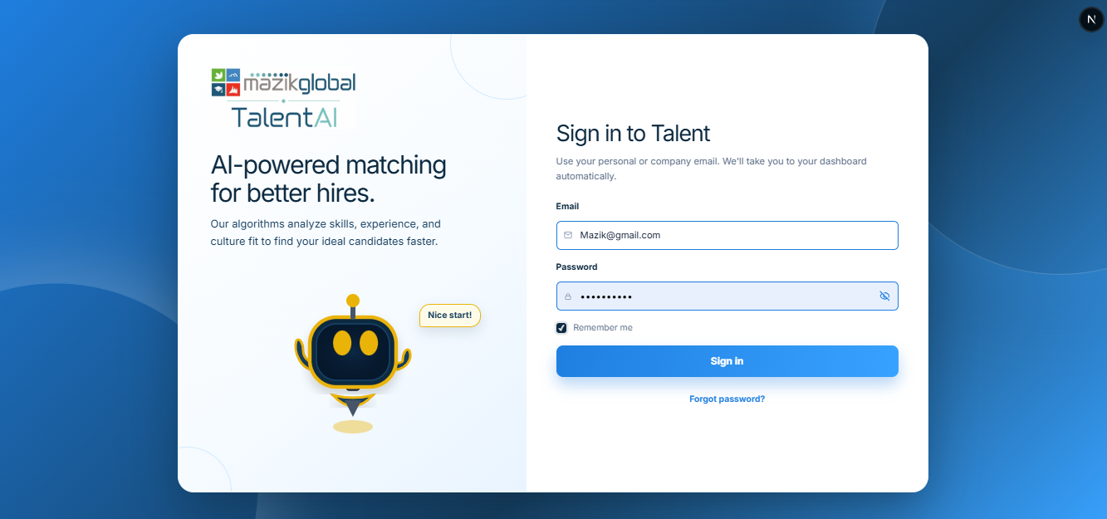

3.2 Who Uses TalentAI
User type | What they do | Dashboard home
Super Admin | Owns the platform. Sets up new client organizations and manages recruiter accounts across all of them. | Super Admin Dashboard
Recruiter | Runs hiring and post-hire operations for their organization — inviting candidates, reviewing documents, managing offers, and supporting employees. | Recruiter Dashboard
Candidate | A person who has accepted an invitation and is completing onboarding before their first day. | Candidate Dashboard
Employee | A person who has joined the organization and now uses the platform for their ongoing profile, learning, career growth, and support needs. | Employee Dashboard

3.3 The Journey Through TalentAI
Invite & Hire → Onboard & Verify → Provision IT → Employ & Support → Develop & Grow
Every stage can be completed by clicking through the dashboard, or by simply asking the AI assistant to do it for you. The rest of this manual follows that same order, starting with how to sign in.

4. Getting Started

4.1 How You Get Access
- Recruiters: created by a Super Admin, or self-register and verify their email/OTP before their account becomes active.
- Candidates: receive an email invitation from a recruiter containing a personal link — there is no public candidate sign-up page.
- Employees: your candidate account automatically becomes your employee account once you are hired — you do not create a new account or lose any information you already entered.
- Super Admins: sign in through a private, unpublished link that is never shown anywhere in the regular site — only someone who already has that exact link can reach it.

4.2 Signing In
- Go to the sign-in page (or use the link from your invitation email).
- Enter your email address and password.
- If this is your first time, you may be asked to verify your email with a 6-digit code sent to your inbox.
- Employees can sign in with either their personal email or their company email — both use the same password.

4.3 Registration (Recruiters)
- Fill in your name, email, phone number, and a password.
- Check your email for a 6-digit verification code.
- Enter the code to activate your account. Codes expire after a short window — use “Resend code” if needed.

4.4 Accepting a Candidate Invitation
- Open the invitation email and click the personal link (it works only for you and expires after a set number of hours).
- Set your password and confirm your details.
- You will land directly in the onboarding wizard to begin filling in your information.

4.5 Password Reset
- On the sign-in page, choose “Forgot password”.
- Enter your email address. You will receive a 6-digit reset code.
- Enter the code and choose a new password.

4.6 Changing Your Password (While Signed In)
Go to the Security section of your Profile page and enter your current password plus a new password twice to confirm. No code is required for this in-session change. For employees, changing your password updates both your personal and company email logins at once.

4.7 Account Lockouts
For your protection, an account is temporarily locked for 15 minutes after 5 failed sign-in attempts in a row. If this happens, either wait 15 minutes or use “Forgot password” to reset sooner.

4.8 Signing Out & Sessions
Use the Logout option in your account/profile menu (top-right of the header) to end your session at any time. If you are inactive for a period, the platform will time out your session automatically for security and return you to the sign-in page.

5. Navigation

5.1 Dashboard
After signing in, you land on your role's dashboard — a summary view with key numbers, recent activity, and quick links into the areas you use most.

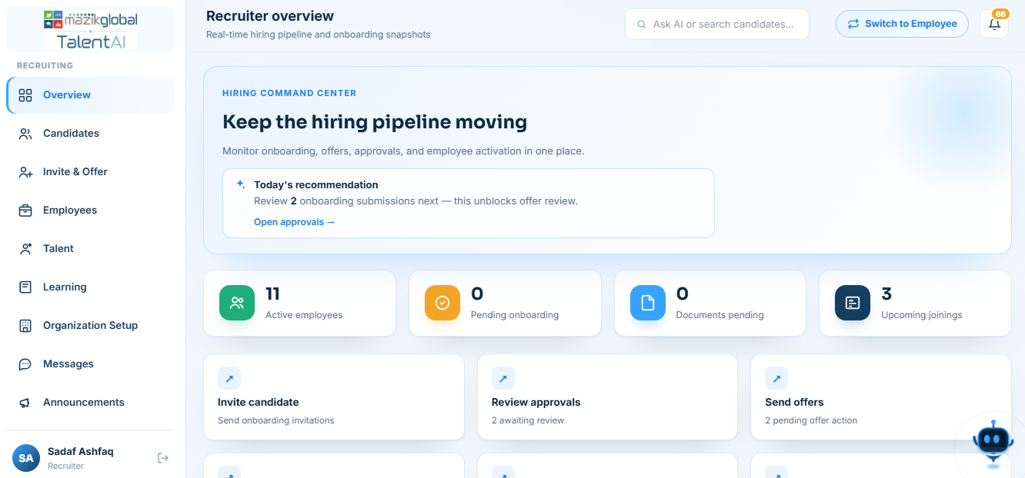

5.2 Sidebar — Recruiter
The recruiter sidebar lists every module a recruiter can be granted, each controlled by its own independent capability switch (Section 7.2):
- Overview — the dashboard landing page
- Candidates — the hiring pipeline
- Invite & Offer — send invitations and manage offers
- Employees — the employee directory
- Talent — skill matrix, pipeline, and internal opportunities
- Learning — course catalog and assignment tools
- Organization Setup — departments, roles, skills, career framework
- Messages — threads with employees/candidates
- Announcements — organization-wide posts
- IT Support — IT provisioning and service requests
- Activity — recent actions/audit-style feed
- AI Assistant — the full-page chat view
- Support — general support tickets
- Profile — your own recruiter profile and security settings

5.3 Sidebar — Employee
- Dashboard — personal landing page
- Onboarding — the post-hire Complete Profile wizard, if not yet finished
- Documents — your uploaded documents
- Learning — course catalog and your enrollments
- My Career — your track, level, and progress
- My Talent — skill matrix and internal opportunities
- AI Assistant — your AI Coach chat
- IT support — raise or track IT requests
- Message HR — your thread with your recruiter/HR contact
- Profile — your personal details and security settings

5.4 Sidebar — Candidate
- Dashboard — your onboarding-status landing page
- Onboarding — the pre-hire onboarding wizard
- Documents — your uploaded documents
- Profile — your personal details
- AI Assistant — chat help for the onboarding process

5.5 Sidebar — Super Admin
- Overview — platform-wide statistics
- Recruiters — every recruiter account, across every organization
- Organizations — every tenant company on the platform
- Invite Recruiter — create a new recruiter account
- Support — escalated/platform-level tickets
- AI Assistant — chat help scoped to platform administration

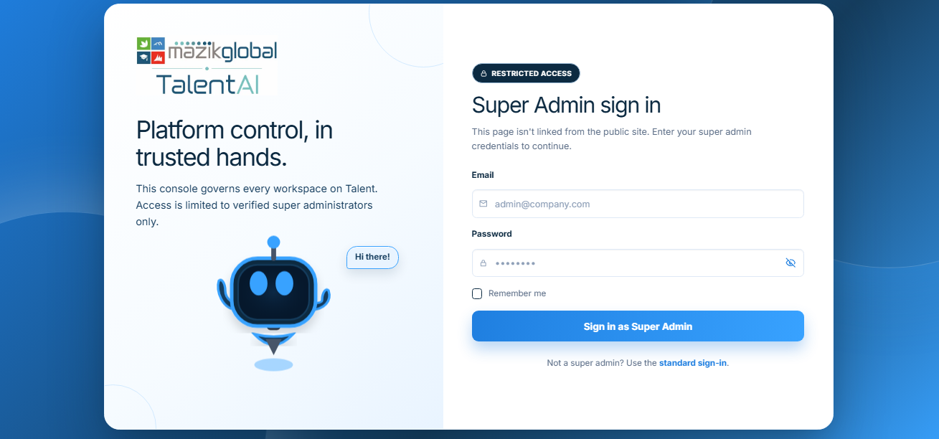

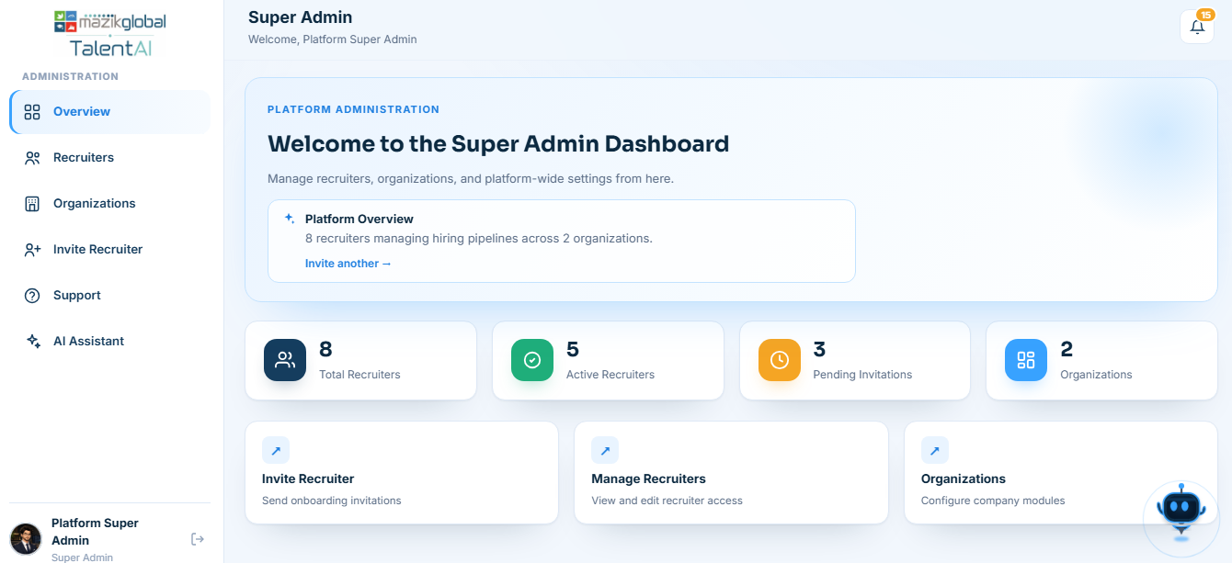

5.6 Header
The top header includes your profile menu (photo, name, sign out), a notification bell showing unread updates, and — for recruiters — a global search box that looks across candidates, employees, and other records at once.
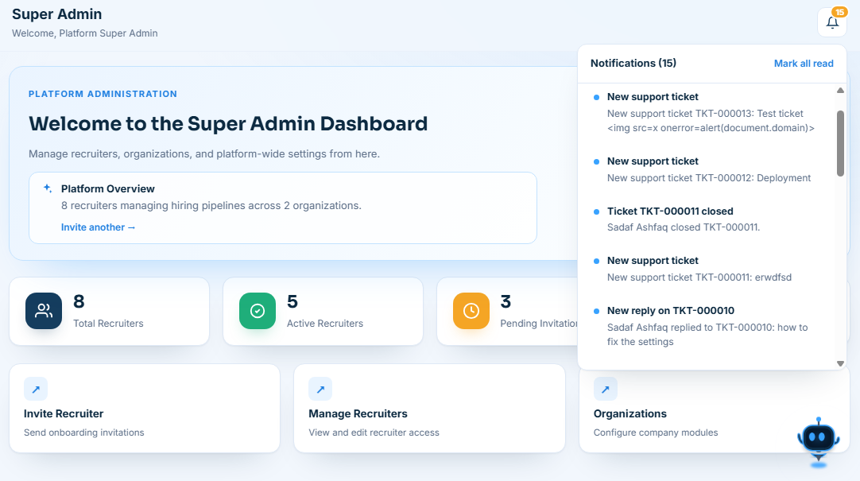

5.7 Search
Use the search bar to quickly find a specific candidate, employee, or record by name or email rather than paging through a long list.

5.8 Tables, Filters & Pagination
Most list screens (candidates, employees, tickets, courses) support filtering by status and paging through results in manageable chunks rather than loading everything at once. Large lists you need outside the platform (like the employee directory) can typically be exported as a spreadsheet file using an Export button on that screen.

5.9 Forms & Modals
Most actions — creating an invitation, verifying a document, replying to a ticket — open as a focused form or pop-up (modal) rather than a full page change, so you don't lose your place in the list behind it.

5.10 Status Indicators
Color-coded badges (for example, on candidates, offers, and tickets) show where a record currently stands — such as Invited, Onboarding, Pending Signature, Signed, Open, In Progress, Resolved — so you can tell a record's state at a glance.

5.11 The AI Assistant
An assistant icon (shown as an animated orb/avatar) is available from your dashboard. Clicking it opens a chat panel where you can type requests in plain language. See Section 10 for full details.

6. Complete Feature Documentation

6.1 Candidate Invitations (Recruiter)
What it does: Starts the hiring process by sending a candidate a personal, tokenized link to begin onboarding.
- Who can use it: Recruiters and Super Admins.
- How to access it: Sidebar → Invite & Offer.
- Enter the candidate's full name (as per CNIC) and email address for a single invitation.
- For a group starting together, switch to bulk mode: download the provided spreadsheet template, fill it in, upload it, and use Preview to check every row for errors before sending.
- Confirm and send. The candidate receives an email with their personal onboarding link.
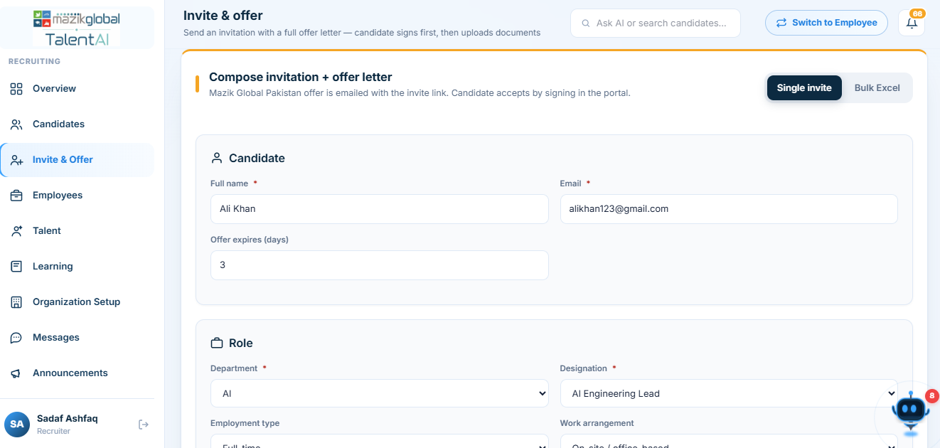
- Expected result: The candidate appears in your Candidates pipeline with status Invited; an invitation record is created with an expiry time.
- Edge cases: An invitation link expires after a set number of hours — expired links can be resent. Re-inviting the same email starts a new hiring cycle rather than overwriting history, so past cycles for a rehire remain visible.

6.2 Candidate Onboarding Wizard (Candidate) — Pre-Hire
What it does: Walks a candidate through a 4-step wizard collecting everything needed before their start date.
- Who can use it: Candidates, on their own record only.
- How to access it: Automatically after accepting an invitation, at the Onboarding page. A progress bar across the top tracks Personal → Education → Skills → Review.

Step 1 — Personal
Titled “Personal & contact information” on screen. Covers your name, date of birth, gender, nationality, national ID number, contact details, and current/permanent address. You can optionally attach your National ID (CNIC/NIC) here — doing so scans the card and auto-fills matching fields for you to review, or you can skip scanning and enter everything by hand.

Step 2 — Education
Add one or more education entries (institution, qualification, dates, and grade); an academic transcript can be attached and auto-read the same way as the ID card in Step 1.

Step 3 — Skills
Titled “Skills & certifications” on screen. Two parts: a Resume & summary section where you upload your Resume/CV (PDF, DOC, or DOCX) and write a short professional summary, and a skills/certifications picker where you select from suggested skills or add your own custom certifications. If you upload a resume, the platform tries to extract your summary, skills, and certifications automatically for you to review and edit.

Step 4 — Review
Titled “Review & submit” on screen. Shows a summary of everything entered and flags any missing sections (personal information, National ID, education and transcript, skills, or Resume/CV) before you can submit.
- Autosave: Your progress is saved automatically as you move between steps and even as you type — you can leave and come back without losing what you've entered.
- Validation: Fields like national ID number, phone number, and date of birth are checked for the correct format before you can continue (for example, you must be at least 14 years old, and dates of birth cannot be in the future).
- Expected result: A completed profile ready for recruiter review; your onboarding progress percentage updates as each step is finished.

6.3 Post-Hire Profile Wizard (Employee) — Complete Profile
What it does: A second, shorter wizard that collects the remaining information only needed once you're actually hired — separate from the pre-hire onboarding wizard in Section 6.2.
- Who can use it: New employees, immediately after conversion from candidate.
- How to access it: Sidebar → Onboarding (shown until completed), at the Complete Profile page.
Its six steps, in order, are: Emergency contact → Banking → References → Policies → Self Declaration → Finish.
- Emergency contact: name, relationship, phone, and optional address of someone to contact in an emergency.
- Banking: your bank name, account holder name, account number, IBAN, branch, and branch code, used for payroll (Section 8.3 for exact validation rules). This information is encrypted before storage.
- References: one or more professional references, each shown as its own “Reference 1,” “Reference 2,” etc. card.
- Policies: acknowledging the organization's key policies/handbook.
- Self Declaration: a final confirmation/declaration step before your profile is marked complete.
- Finish: a confirmation screen closing out the wizard.

6.4 Document Upload & Verification
What it does: Lets a candidate or employee upload identity, education, and other supporting documents, with automatic field extraction to reduce manual typing.
- Who can use it: Candidates and employees (upload their own documents); recruiters (review and verify).
- How to access it: The relevant onboarding step, the standalone Documents page, or an employee's Profile page.
- Choose the document type (e.g. National ID, Passport, Resume, Transcript, bank slip).
- Select or drag a file. Supported formats include PDF, Word documents, and photos/scans of the document.
- The system reads the document and proposes matching profile fields for you to review before saving.
- A recruiter reviews the document and marks it Verified (or flags/rejects it, with a reason) before it counts as complete.
- Expected result: The document appears in your document list with a processing/verified status; extracted fields are proposed for your profile.
- Processing failures: If the system can't read a document clearly, it is queued for manual review rather than being rejected outright — you can still proceed while a recruiter checks it by hand.

6.5 Offer Letters (Recruiter & Candidate)
What it does: Manages the full life of a job offer, from drafting to signature.
- Who can use it: Recruiters (create, send, approve, extend); Candidates (view, sign, negotiate, decline).
- Recruiter: fill in job title, department, employment type, office location, whether the role is remote, reporting manager, start date, monthly salary and currency, plus any allowances (e.g. Housing) and benefits.
- Send the offer — the candidate is notified by email and in-app.
- The candidate reviews the offer, and can accept & sign, propose a counter-offer (negotiate), or decline.
- If negotiated, the recruiter can accept, reject, or counter the candidate's proposed terms.
- Once signed, a recruiter can approve the offer, formally moving the candidate toward hire.
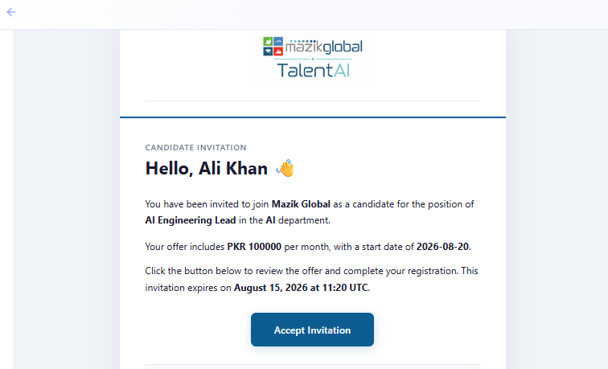
- Signing: Candidates can type/draw a signature or upload a signature image.
- Extensions & reminders: A recruiter can extend an offer's response deadline, or send a reminder if the candidate hasn't responded.
- Expected result: A fully signed, approved offer unlocks the next steps (IT provisioning, employee conversion).
- Restrictions: A candidate can only act on their own offer; only a recruiter/Super Admin can approve or edit-and-resend an offer.

6.6 IT Provisioning
What it does: Requests and tracks the equipment and account access a new hire needs on day one.
- Who can use it: Recruiters (send provisioning requests, manage kits); Candidates/new hires (submit their intake form via a personal link, no login required).
- A recruiter selects (or creates) an IT kit — a predefined bundle of equipment and software/license needs.
- The recruiter sends the provisioning request to the candidate, individually or in bulk for a group starting together.
- The candidate opens their personal link and confirms/edits their equipment details (no account needed to do this).
- IT staff fulfill the request; the recruiter can send reminders if it's outstanding.
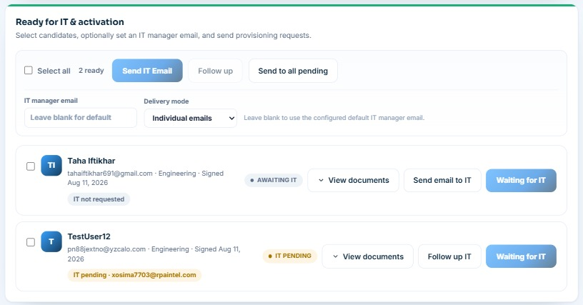
- Expected result: A completed provisioning record ready for the employee's first day, with company email/account details available once assigned.

6.7 Candidate → Employee Conversion
What it does: Turns a signed, approved candidate into a full employee record without asking them to re-enter anything.
- Who can use it: Recruiters.
- How to access it: From the candidate's detail page, once ready-for-conversion criteria are met (signed offer, verified documents).
- Expected result: A new employee ID is generated, a company email can be assigned, and the person now appears in the Employees directory with their full onboarding history preserved.

6.8 Employee Profile & Directory
What it does: Gives every employee a personal profile, and gives recruiters a searchable directory of the whole organization.
- Who can use it: Employees (their own profile); Recruiters (the full directory).
- Employees can: complete any remaining profile fields, upload a profile photo, view/reveal their company email password (via a one-time code sent for security), and update personal information.
- Recruiters can: view any employee's detail page, assign IT assets, schedule orientation, set banking details, remind an employee to finish their profile, record career events, and process an exit if the employee leaves.
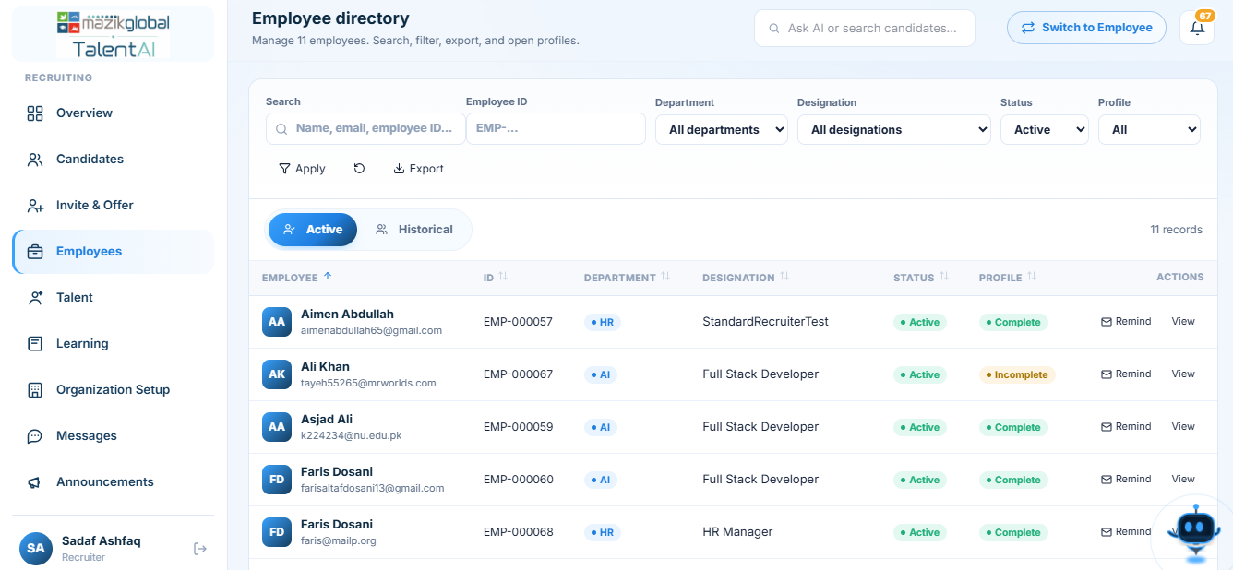

6.9 Learning
What it does: Gives employees access to a live catalog of courses (sourced from Coursera and Microsoft Learn, plus courses your organization manages directly), tracks progress, and recommends what to take next.
- Who can use it: Employees (browse, enroll, track progress, upload certificates); Recruiters/Admins (assign courses, manage the catalog, verify certificates, configure providers).
- Browse the catalog by category, source, or skill; bookmark courses for later.
- Start a course and update your progress as you go; recommendations are generated based on your role, skills, and any skill gaps identified.
- Upload a certificate when you complete a course elsewhere — a recruiter verifies it before it counts toward your record.
- Recruiters can assign specific courses to one or many employees and send reminders.
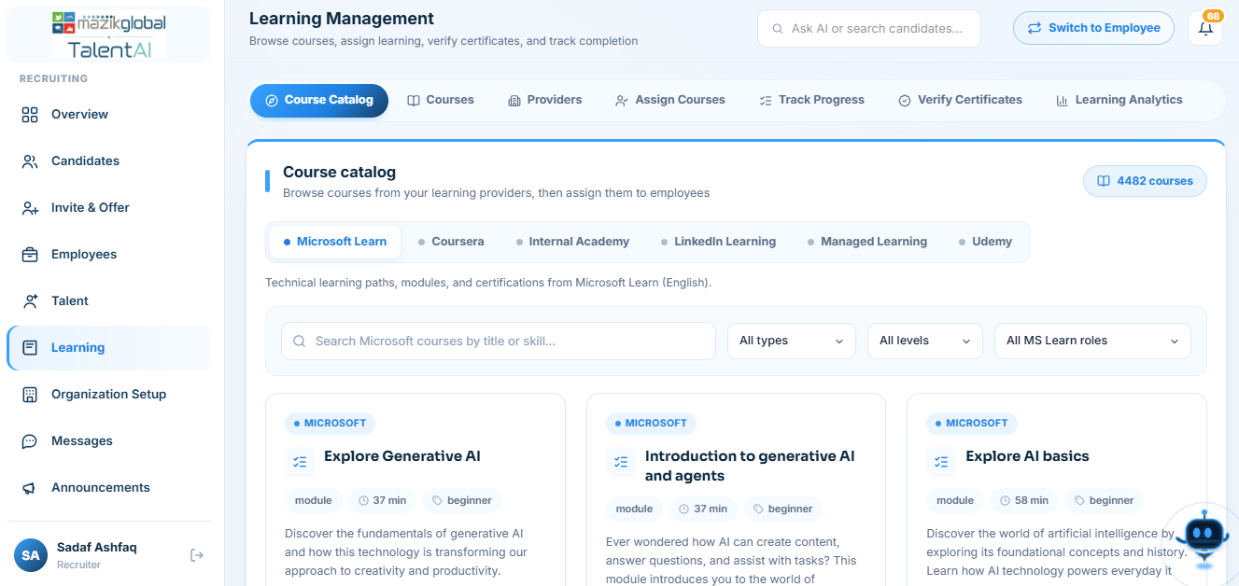

6.10 Career Framework & Talent
What it does: Shows employees their career track, level, and what's needed to advance; gives recruiters organization-wide visibility into skills and promotion readiness.
- Who can use it: Employees (My Career and My Talent pages); Recruiters/Admins (Talent module, with Overview, Employees, Pipeline, and Opportunities tabs, plus Organization Setup for configuring tracks/levels).
- Employees can view their career track and level, a skill matrix, their career journey/timeline, and any achievements earned.
- Recruiters can configure tracks/levels, assign employees to them, run promotion-readiness and career-progress reports, evaluate competencies, and manage internal job opportunities and development plans.
- Internal Opportunities: employees can browse and apply to open internal roles posted by recruiters, under the Opportunities tab.
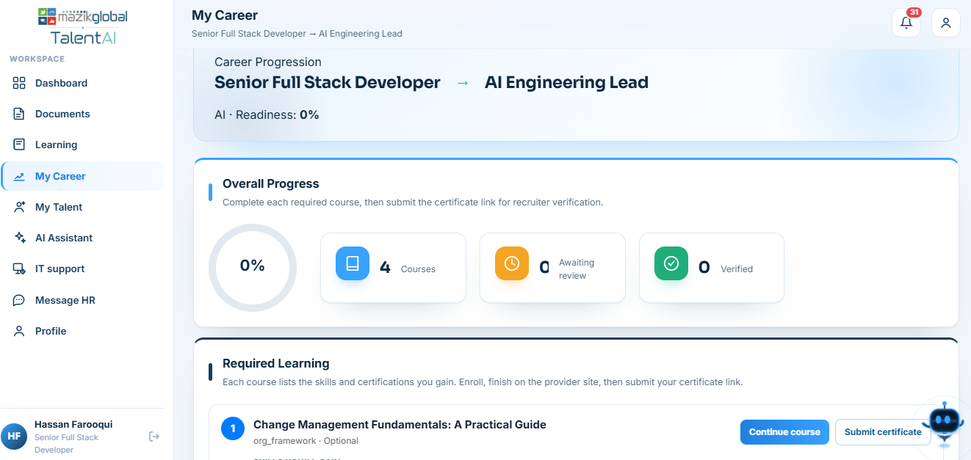

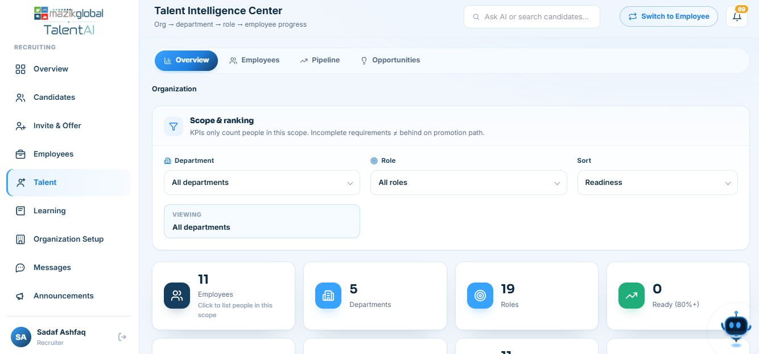

6.11 Support Tickets & IT Service Requests
What it does: Lets anyone raise an issue (technical or general HR) and track it to resolution.
- Who can use it: All roles can raise a ticket for themselves; Recruiters/Super Admin/IT officers triage, assign, reply to, and close tickets.
- Open Support (or IT Support), describe the issue, choose a category/priority, and attach a file if helpful.
- Track replies and status changes on the ticket — Open, In Progress, Resolved, Closed.
- Merge duplicate tickets or reopen a closed one if the issue recurs (staff-only actions).
- A public, no-login IT support intake link is also available for pre-employment/edge cases where the person doesn't yet have platform access.

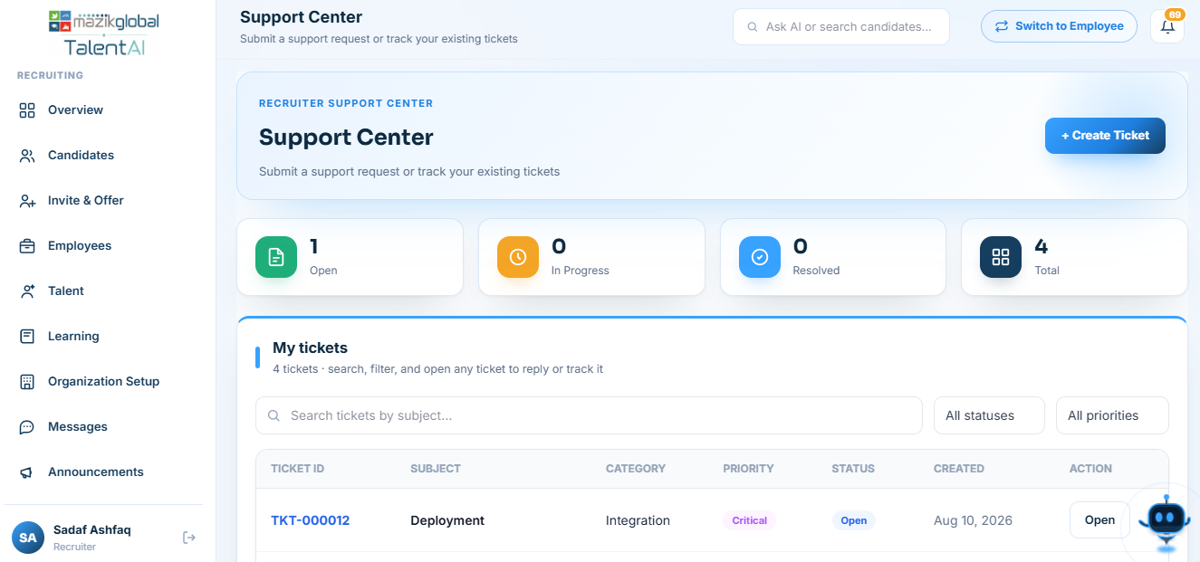

6.12 Messages
What it does: A direct messaging thread between an employee/candidate and their assigned recruiter/HR contact — separate from support tickets, for ongoing conversations.
- Who can use it: Employees/Candidates (start/reply to their thread, labeled Message HR); Recruiters (reply, close threads).

6.13 Announcements
What it does: Organization-wide news/updates posted by a recruiter or admin and visible to relevant employees.
- Who can use it: Recruiters/Admins create, edit, and remove announcements; all roles can view the ones relevant to them.

6.14 Organization Setup (Recruiter/Admin)
What it does: Lets an organization define its own departments, job roles, required skills, certifications, course requirements, and promotion rules — the framework everything else (Learning, Career, Talent) is built on.
- Who can use it: Recruiters with the Organization Setup capability enabled, and Super Admins.
- Includes import/export tools so an organization's framework can be set up from a spreadsheet rather than entered field by field.
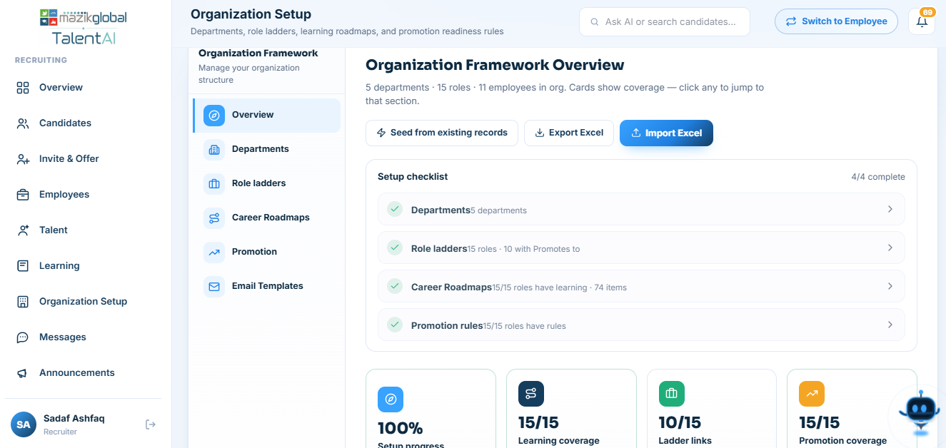

6.15 Platform Administration (Super Admin)
What it does: Manages the platform at the tenant level — every client organization and every recruiter account.
- Onboard a new client organization onto the platform.
- Invite and manage recruiter accounts, including turning individual modules on/off for a specific recruiter (capabilities) independent of their base role.
- View platform-wide statistics and organization health.
- Triage support tickets that need attention above a single organization.

7. Role-Based User Guides

7.1 Super Admin
What the role is: The platform owner, with unrestricted access.
- Can access: Every module and every organization's data; a dedicated Super Admin dashboard with platform-wide statistics.
- Can do: Create/edit/remove organizations, invite and manage recruiters (including granting or revoking their per-module capabilities), triage escalated tickets.
- Cannot access: Nothing is restricted for this role — it holds every defined permission.
- Special workflow: Signs in only through the private, unpublished route — never the standard sign-in page — and that link is intentionally not shown anywhere else in the product.

7.2 Recruiter
What the role is: Runs hiring and post-hire operations for one organization.
- Can access: Candidates, Employees, Invitations, Offers, Documents, IT & Support, Learning, Talent, Organization Setup, Messages, Announcements, Reporting, the AI Assistant, and their own Profile — subject to the capability toggles described below.
- Cannot access: Other organizations' data, or any Super Admin-only administration screens.
- Role-specific workflow — capabilities: In addition to being a recruiter, each recruiter has a set of per-module on/off switches (called capabilities) that a Super Admin (or an org-level setting) controls — for example, a recruiter might be fully able to manage Candidates but have the Learning module switched off for them specifically. The full list of switchable modules is: Overview, Candidates, Invite & Offer, Employees, Talent, Learning, Organization Setup, AI Assistant, Messages, Announcements, IT, Reporting, Profile, and Support. If a sidebar item you expect to see is missing, this is the most common reason — check with your administrator rather than assuming something is broken.

7.3 Candidate
What the role is: A person who has accepted an invitation and is completing onboarding, pre-hire.
- Can access: The 4-step onboarding wizard (Personal, Education, Skills, Review), their own documents, their own offer letter, and their profile view.
- Cannot access: Learning, Career, or Talent modules — these are employee-only features that unlock once hired. Cannot see any other candidate's or employee's information.
- Role-specific workflow: Once hired (offer signed, approved, and converted by a recruiter), a candidate becomes an employee automatically — all the information already entered carries over; nothing needs to be re-entered. You'll then be guided into the shorter, 6-step Complete Profile wizard (Section 6.3) to finish the details only needed post-hire.

7.4 Employee
What the role is: A person who has joined the organization and uses the platform for their ongoing profile, growth, and support needs.
- Can access: Their profile, Learning, an AI Coach assistant, My Career, My Talent (skill matrix, journey, internal opportunities), Documents, their Offer record, IT support, general Support tickets, and Message HR with their recruiter.
- Cannot access: Any other employee's private data, recruiter-only screens, or platform administration.
- Role-specific workflow: Can sign in with either their personal or company email; if they leave the organization, their company-email sign-in is disabled going forward but their personal-email login to the historical record remains available to the organization's records.

8. Forms & Fields
Field lists below reflect the actual validation rules built into the platform's forms.

8.1 Onboarding — Personal & Contact Information
Field | Purpose | Required | Validation | Example
First / last name | Legal name | Yes | 1–80 characters | Fatima Khan
Date of birth | Age/eligibility check | Yes | Cannot be in the future; must be at least 14 years old | 1998-04-12
Gender | Demographic record | Yes | Male / Female / Other / Prefer not to say | —
Nationality | Identity record | Yes | 2–80 characters | Pakistani
Marital status | HR record | Yes | Single / Married / Divorced / Widowed / Other | —
Blood group | Emergency/medical record | Yes | A+, A-, B+, B-, AB+, AB-, O+, O-, or N/A | O+
National ID (CNIC/NIC) | Identity verification | Yes | Valid national ID number format | 12345-1234567-1
Father's name | Identity record | Yes | 2–120 characters | —
Current & permanent address | Contact record | Yes | 3–300 characters; “Same as current” checkbox available | —
City / State / Country / Postal code | Contact record | Yes | Standard length checks | Karachi / Sindh / Pakistan / 74200
Alternate phone | Contact record | No | Valid phone format if provided | +92 300 1234567

8.2 Post-Hire — Emergency Contact
Field | Required | Validation
Name | Yes | 2–100 characters
Relationship | Yes | 2–60 characters
Phone | Yes | Valid mobile number format
Alternate phone / Address | No | Standard format checks if provided

8.3 Post-Hire — Banking Details
Field | Required | Validation
Bank name | Yes | 2–100 characters
Account holder name | Yes | 2–100 characters
Account number | Yes | 4–40 characters
IBAN | Yes | Must match a valid IBAN pattern
Branch / Branch code | Yes | Standard length checks
SWIFT code | No | Up to 20 characters if provided

8.4 Offer Letter — Key Terms
Field | Required | Notes
Job title / Department | Yes | 2–120 characters each
Employment type | Yes | Defaults to “Full-time”
Reporting manager | Yes | 2–120 characters
Start date | Yes | Accepts natural-language dates (e.g. “next Monday”), normalized automatically
Monthly salary / Currency | Yes | Salary must be zero or greater; currency defaults to PKR
Allowances / Benefits | No | Add any number of named allowance (e.g. Housing) or benefit line items
Offer expiry | No | 1–90 days; falls back to a platform-wide default if left blank
Message to candidate | No | A short personal note included with the offer

9. Notifications

9.1 In-App Notifications
A bell icon in the header shows unread notifications. Click it to see recent updates and mark them as read. Notifications are generated across nearly every module — offers, IT requests and provisioning, learning, support tickets, employee actions, invitations, and more.

9.2 Email Notifications
Key actions also trigger an email so you don't have to be signed in to know something needs your attention — invitations, OTP/verification codes, offer letters and reminders, password resets, and IT provisioning/service-request updates are all sent by email in addition to appearing in-app.

9.3 Common Triggers
Trigger | Who is notified
A candidate is invited | The candidate (email with their onboarding link)
An offer is sent, signed, negotiated, or approved | Both the candidate and the recruiter, depending on the step
A document needs review, or is verified/rejected | The recruiter (needs review) or the candidate/employee (verified/rejected)
An IT provisioning or service request changes state | The requester and, where relevant, IT staff
A course is assigned, or a certificate needs verification | The employee (assignment) or the recruiter (certificate to verify)
A support ticket receives a reply or changes status | Whoever is not the one who made the change
A profile or onboarding step is incomplete | The candidate/employee, as a reminder from a recruiter

10. AI Features

10.1 What the AI Assistant Is
Every role has access to a conversational assistant (shown as an orb-style avatar) that can carry out real actions on your behalf — not just answer questions. It uses the exact same permissions and underlying actions as the buttons and forms on your dashboard, so it can never do anything you personally aren't allowed to do, and it can never see another organization's or another person's private data.
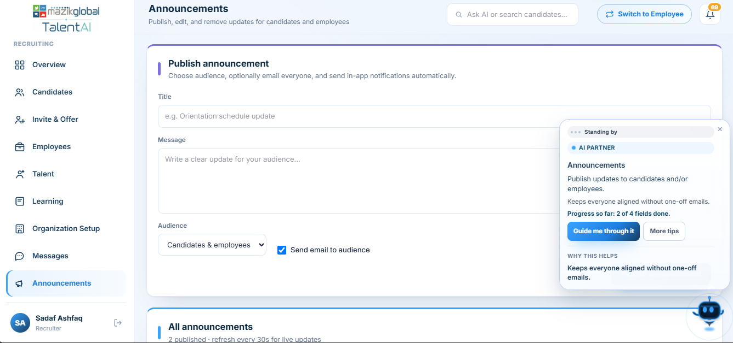

10.2 What You Can Ask It To Do
- Recruiters: invite a candidate, check someone's status, review/verify documents, send or extend an offer, assign IT assets, schedule orientation, assign a learning course, post an announcement, search for a person or a skill, and much more — for one person or in bulk.
- Candidates: check onboarding status, get help understanding a form field, see offer details.
- Employees: check learning recommendations, ask about career progress, get help completing their profile, raise a support request.
- Super Admins: platform-level questions and actions within their scope.

10.3 How to Use It
- Click the assistant icon on your dashboard to open the chat panel.
- Type your request in plain language — you don't need any special commands or syntax.
- The assistant will either complete the action directly, ask a clarifying question if something is missing, or show a confirmation step before anything irreversible happens (like rejecting a document or sending a bulk reminder).
- Where relevant, the assistant shows a button to take you straight to the right screen instead of describing navigation steps.

10.4 AI-Assisted Document Processing
When you upload a document, the assistant's document-processing view shows what's happening — scanning, extracting fields, and matching them to your profile — and proposes the extracted values for you to confirm rather than filling them in silently.

10.5 Confirmation & Safety
For actions that can't easily be undone (rejecting a document, deleting an announcement, approving an offer, bulk-sending reminders), the assistant will always ask you to confirm before proceeding — it will never take an irreversible action silently.

10.6 Limitations & What To Do If It Can't Help
- The assistant only knows about your own role's data and actions — it cannot act outside what you personally are permitted to do.
- If the assistant can't complete something (for example, if it's momentarily unavailable), it will still be able to answer basic status questions using its own fallback, and you can always fall back to the regular dashboard screens and buttons to complete the same task.
- The assistant will never share passwords, one-time codes, or reset codes with you in chat — for those, it will point you to the Security section of your profile or the sign-in page's password-reset option.

11. Documents & File Management

11.1 Upload
Documents can be uploaded from the onboarding wizard's document-attachment fields, the standalone Documents page, or directly from your profile. Accepted formats generally include PDF, Word documents (.docx), and image files (photos or scans).

11.2 Size Limits
There is a maximum file size per upload (10 MB by default). If your file is larger, compress it or take a lower-resolution photo before uploading.

11.3 Automatic Field Extraction
Supported document types — national ID, passport, resume/CV, and academic transcripts — are automatically scanned and key fields (like your name, ID number, or graduation year) are proposed to pre-fill your profile, saving you from retyping them. You always get to review the proposed values before they're saved.

11.4 Bank Slip Analysis
For banking setup, a bank slip/statement can be analyzed to help verify your banking details against what you've entered, flagging any mismatches for you or your recruiter to double-check.

11.5 Preview & Download
Uploaded documents can be previewed or downloaded again at any time from your document list. Recruiters have the same access for documents belonging to the people they manage.
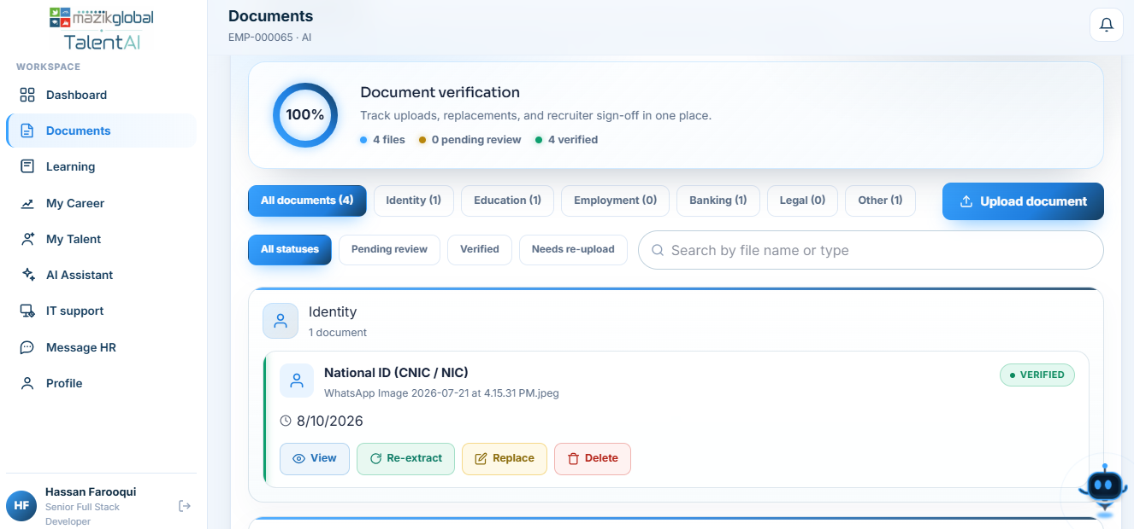

11.6 Verification
A recruiter reviews each document and marks it Verified before it counts toward your onboarding completion. If something looks wrong, they can flag it or ask for a re-upload, with a reason shown to you.

11.7 Deleting a Document
You (or a recruiter, on your behalf) can remove a document you've uploaded if it was uploaded in error or needs to be replaced.

11.8 Processing Failures
If the system can't confidently read a document (poor scan quality, an unsupported layout, etc.), it doesn't reject the upload — it stores the file and flags it for manual review by a recruiter, so you're never blocked by a scan the system couldn't parse automatically.

12. Troubleshooting
Problem | Possible cause | What to do
I can't sign in | Wrong password, or account temporarily locked after 5 failed attempts | Double-check your password; if locked, wait 15 minutes or use Forgot Password
My invitation link doesn't work | The link has expired, or has already been used | Ask your recruiter to resend the invitation
I didn't receive my verification code | Email delay, spam filtering, or the code expired | Check your spam folder; use “Resend code” if a few minutes have passed
My uploaded document isn't showing extracted data | The scan quality was too low, or it's an unsupported document type for auto-fill | The document is still saved and can be manually reviewed by your recruiter — you can also try re-uploading a clearer scan
My onboarding step won't save | A required field is missing or doesn't match the expected format (e.g. date of birth, ID number, phone number) | Check for a red validation message under the field in question and correct the format
I can't see a module I expect (e.g. Learning) | For candidates, some modules (Learning/Career/Talent) are only available after you're hired as an employee. For recruiters, an administrator may have switched that module off for you specifically | Candidates: this unlocks automatically once hired. Recruiters: contact your Super Admin/administrator about your module access
I signed an offer but nothing seems to have happened | The offer still needs recruiter approval as a separate step | Contact your recruiter to confirm approval — signing and approval are two distinct steps
I can't sign in with my company email after leaving | Company-email sign-in is disabled for employees who have exited the organization | Sign in with your personal email instead, which remains linked to your historical record
The AI assistant gave a generic answer instead of taking action | The assistant's live AI connection may be temporarily unavailable, in which case it uses a basic fallback for status questions only | Use the regular dashboard screens/buttons to complete the action directly
A support ticket I submitted seems stuck | It may be awaiting assignment or a reply from staff | Check the ticket's activity log for updates, or add a reply asking for a status update
If none of the above resolves your issue, contact your recruiter/HR contact, or raise a Support ticket describing the problem (Section 6.11).

13. Frequently Asked Questions

Do I need to create a new account when I'm hired?
No. Your candidate account automatically becomes your employee account — everything you entered during onboarding carries over, and you'll simply continue into the shorter Complete Profile wizard for the remaining post-hire details.

Can I use the platform on my phone?
The platform is a standard web application accessible from any modern browser; specific mobile-app support is not part of what was reviewed for this manual.

Who can see my documents?
Only you and the recruiter(s) managing your hiring/employment can see your uploaded documents. Other candidates and employees cannot.

What happens if I decline an offer?
The offer is marked declined and your recruiter is notified. You can discuss next steps directly with them.

Can I negotiate my offer?
Yes — you can propose a counter-offer, which your recruiter can accept, reject, or counter again.

How do I know if my document was accepted?
Its status will change to Verified once a recruiter has reviewed it. Until then it may show as pending/processing.

Is the AI assistant a real person?
No — it's an automated assistant. It can take real actions on your behalf, but it always follows the same permission rules as your own account and will confirm before doing anything irreversible.

Why can't I access a module I think I should have?
For recruiters, an administrator can switch individual modules on/off per person, independent of your general role. For candidates, some modules (like Learning) only unlock after you become an employee.

What should I do if I forget my password?
Use “Forgot password” on the sign-in page — you'll receive a 6-digit code by email to set a new password.

What's the difference between the onboarding wizard and the Complete Profile wizard?
The onboarding wizard (Personal, Education, Skills, Review) is what a candidate completes before being hired. The Complete Profile wizard (Emergency contact, Banking, References, Policies, Self Declaration, Finish) is a separate, shorter set of steps you complete right after becoming an employee.

14. Glossary
Term | Meaning
Recruiter | The staff role that runs hiring and post-hire operations for an organization
Candidate | A person who has accepted an invitation and is completing onboarding, before their start date
Employee | A person who has been hired and now uses the platform for ongoing work-life needs
Super Admin | The platform-owner role with access to every organization and account
Organization | A single company/client using TalentAI — your data is only ever visible within your own organization
Onboarding | The 4-step process (Personal, Education, Skills, Review) a candidate completes before their first day
Complete Profile wizard | The 6-step post-hire process (Emergency contact, Banking, References, Policies, Self Declaration, Finish) an employee completes right after being hired
Offer letter | The formal job offer document a candidate reviews and signs
IT Provisioning | The process of requesting and tracking a new hire's equipment and account access
Capability | A specific module a recruiter has (or doesn't have) turned on for their account, separate from their general role
Verification | A recruiter's confirmation that an uploaded document is genuine and correctly matches your profile
Career track / level | Your organization's defined career ladder and where you currently sit on it
AI Assistant | The platform's built-in conversational helper that can take real actions on your behalf
OTP | One-Time Password — a 6-digit code sent to your email to verify an action like registration or password reset
Internal opportunity | An open role within your own organization that employees can browse and apply to

